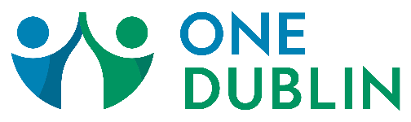
Spiritual Support Resources

Name | Denomination | Website | Phone
CHROMA Columbus | Non-denominational | chromacolumbus.org | 614.653.8085
Cypress Church | Wesleyan | cypresschurch.tv/campuses/dublin | 614.878.8192
Discover Christian Church | Non-denominational | discovercc.org | 614.889.1572
Dublin Baptist | Southern Baptist | dublinbaptist.com | 614.889.2307
Dublin Community Church | United Church of Christ | dccucc.com | 614.889.1026
Indian Run United Methodist Church | United Methodist | indianrun.org | 614.889.7728
Living Hope Church | Southern Baptist | livinghopecolumbus.org | 937.738.7114
NOOR Islamic Cultural Center | Islamic | noorohio.org | 614.527.7777
Northwest Presbyterian Church | Presbyterian | npcdublin.org | 614.799.2300
Nuvo Church | Non-denominational | nuvochurch.org | 614.407.5259
Prince of Peace Lutheran Church | ELCA Lutheran | princeofpeacedublin.org | 614.766.6377
St. Brigid of Kildare | Roman Catholic | stbrigidofkildare.org | 614.761.3734
St. Patrick’s Episcopal Church | Episcopal | pats-dublin.org | 614.766.2664
The Church of Jesus Christ of Latter-day Saints | LDS | local.churchofjesuschrist.org/us/oh/dublin | 614.291.4003
Vineyard Columbus Sawmill | Non-denominational | vineyardcolumbus.org/sawmill | 614.259.5439
Vista Community Church | Non-denominational | vistacommunitychurch.org | 614.718.2294

